Uploading Microsoft Office Templates to SharePoint

Introduction
The Microsoft 365 suite of document solutions needs to have a consistent look and feel, delivered by administrators in a simple way. Therefore, it is essential for brand managers to be able to easily distribute a unified set of document templates to their organization. As part of Microsoft 365, SharePoint offers the possibility to store and share company templates from a designated location.
This document outlines the process of how to deploy and use Corporate Branded Office Templates in SharePoint Online. The Intended Audience of this document is Microsoft 365 Administrators – specifically the SharePoint Administrators, as well as Corporate Branding Staff.

Requirements
No matter where employees start authoring a document, it should use the correct fonts and branding. There are many places to start a document:
- Desktop Word
- Word Online via SharePoint
- Word Online via OneDrive for Business
- Word Online via Microsoft 365 Groups starting at Outlook, directed to SP Sites
- Word Online via Microsoft 365 Groups starting at OWA
- Within Teams interface
- Within Teams in SharePoint
In SharePoint, you can you upload a content type Word Template, PowerPoint Template and other Microsoft Office workloads and have it appear on the “New” option in the SharePoint ribbon and in the desktop Office apps for everyone.
Below we’ll demonstrate succinctly and articulately clear instructions how to deploy and use Corporate Branded Office Templates in SharePoint Online.

SharePoint Configuration
Connect to Microsoft 365 SharePoint as a Microsoft 365 Global Administrator that has had a SharePoint license allocated.

Create a content type for a document template.
Head to: https://yourdomain.sharepoint.com/SitePages/Home.aspx

Site Settings
Go to the Gear Icon, top right on the ribbon, select Site Settings from the Site Actions menu.
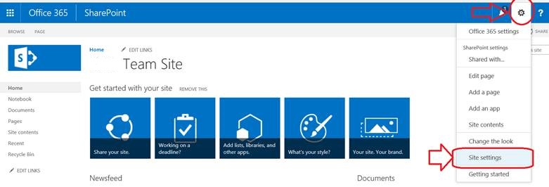

Site Content Types
Under the Web Design Galleries section of the Site Settings page, click Site content types.
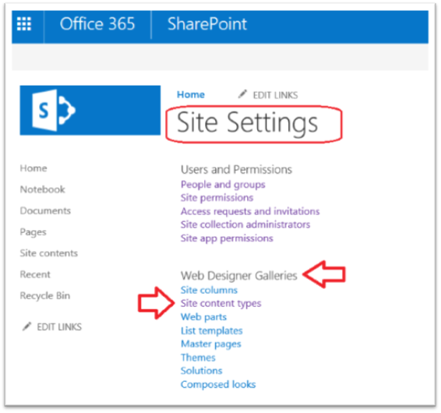

Click Create:
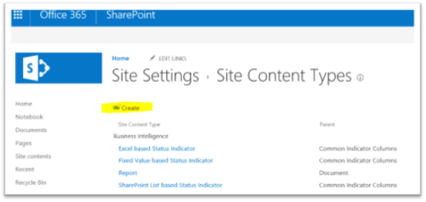

New Site Content Type
On the New Site Content Type page, do the following:
- In the Name field type “CLIENT Excel Template”
- In the Description field type “Create new Excel Workbooks in this library”
- At Select parent content type from choose “Document Content Types” from drop down list
- At the Parent Content Type drop-down list select “Document”
- For Group, choose an Existing Group “CLIENT Templates” for the “Put this site content type into”
- Click OK.

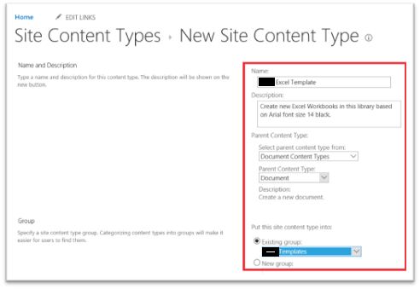

Advanced Settings
On the Site Content Types > CLIENT Excel Template page, under Settings, click Advanced Settings.

In the Document Template section, select the radio button for Upload a new document template, click Browse, and then choose your pre-created Template.

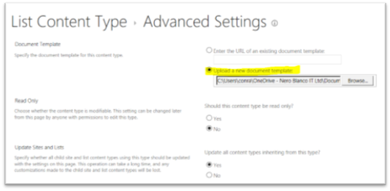
Click OK.
Note: You can also add a new Word, PowerPoint, or OneNote template by repeating the above steps for each file type. You can also create multiple and different templates of the same file type.

Display the new template as a choice when creating new documents
Now that we have created content types for PowerPoint, Word and Excel templates, we need to add the content types to a Document Library. This step ensures that they will appear as choices from the New Document command on the ribbon.

Library Settings
Navigate to the library to which you want to associate the new content types.
Again, select the Gear Icon on the ribbon but this time choose Library Settings.
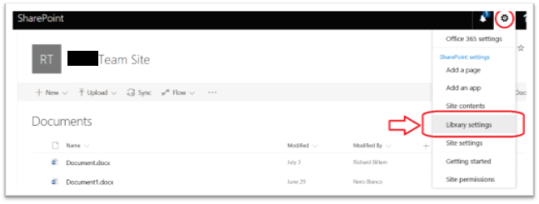

Documents Advanced Settings
Under General Settings, click Advanced Settings.
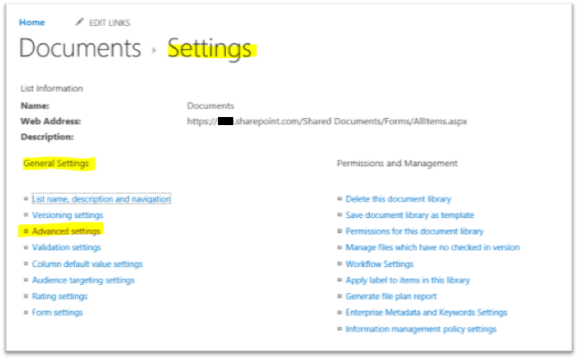

Allow management of content types
In the Content Types section, click Yes under Allow management of content types, and then click OK.

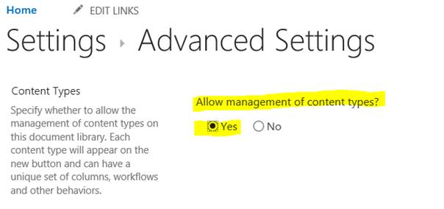

Add Existing Content Types
On the Library Settings page, under Content Types, click Add from existing site content types.
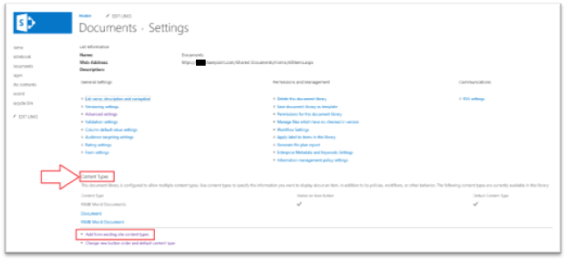

On the Add Content Types page, choose CLIENT Templates from the Select site content types from drop down list

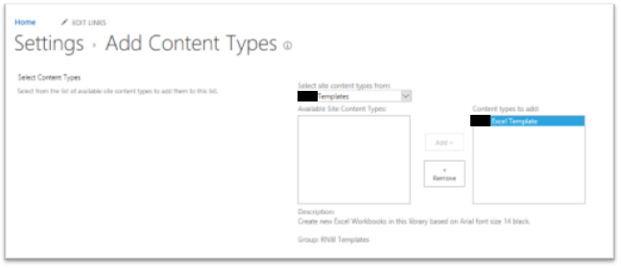
Under Available Site Content Types, look for and select the new content types to associate to this library. In our case “CLIENT Excel Template” and click Add.
Click OK.

Set up the new template for end users

To get the templates to appear for each user, the following needs to happen:

The user needs to navigate to the SharePoint site, look in the Documents area for the folder that holds the templates, and then sync that folder to their OneDrive.

- On the Microsoft 365 app launcher, select SharePoint, and then select the site with the files you want to sync.
- Select Documents or navigate to the subfolder you want to sync.
- Select Sync. (You only need to do this once on a computer to set up syncing on that computer. After you set up syncing, the files sync automatically.)
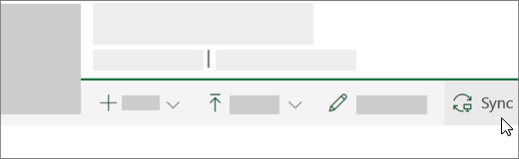

- If your browser requests permission to use "Microsoft OneDrive," confirm that this is okay.
Important: If a screen appears stating "Which library do you want to sync?", your site hasn't been set up to sync with the OneDrive sync app. In that case, see Let users sync SharePoint files with the new OneDrive sync app.

Sync the OneDrive folder locally

The files sync to a folder on your PC that has the name of your organization (for example, %userprofile%\Contoso). This folder is automatically added to the left pane in File Explorer. You can’t select to sync to a different location.
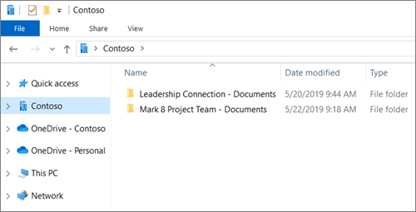

The user then needs to ensure that the templates have downloaded onto their computer locally and are available offline.

For Windows

- Right-click on the OneDrive icon in the system tray and click Settings.
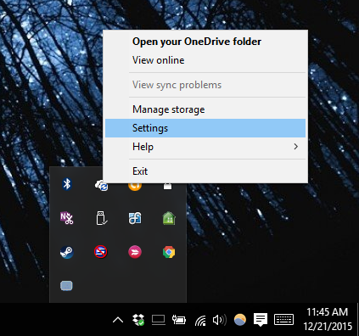

- Click "Choose folders" to select the folders to sync.
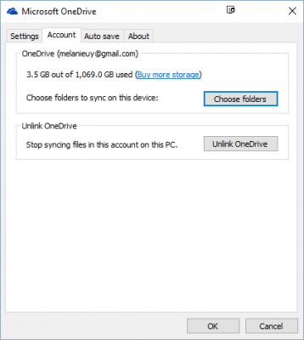

- Check the boxes next to the folders you want to sync with your PC. Note that by default all files not in a folder will be synced.
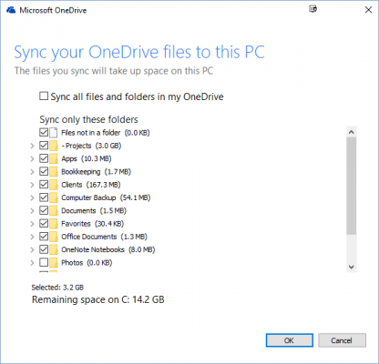

- Click OK.

For Mac

- It’s crucial that all users who are going to use the global templates have OneDrive setup on their Mac to synch with the directory. To set up synch of the folder, navigate to the OneDrive app.
- Click More > Preferences.
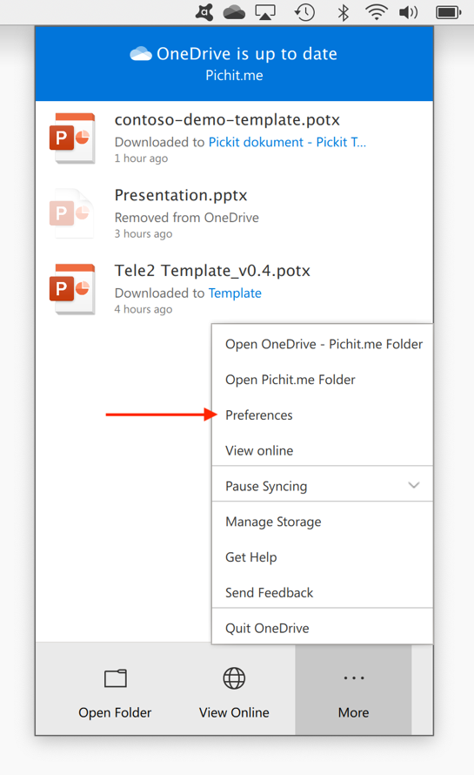
- Make sure you see the company folder as part of the list of synced folders. Click Choose folders and select the template location.
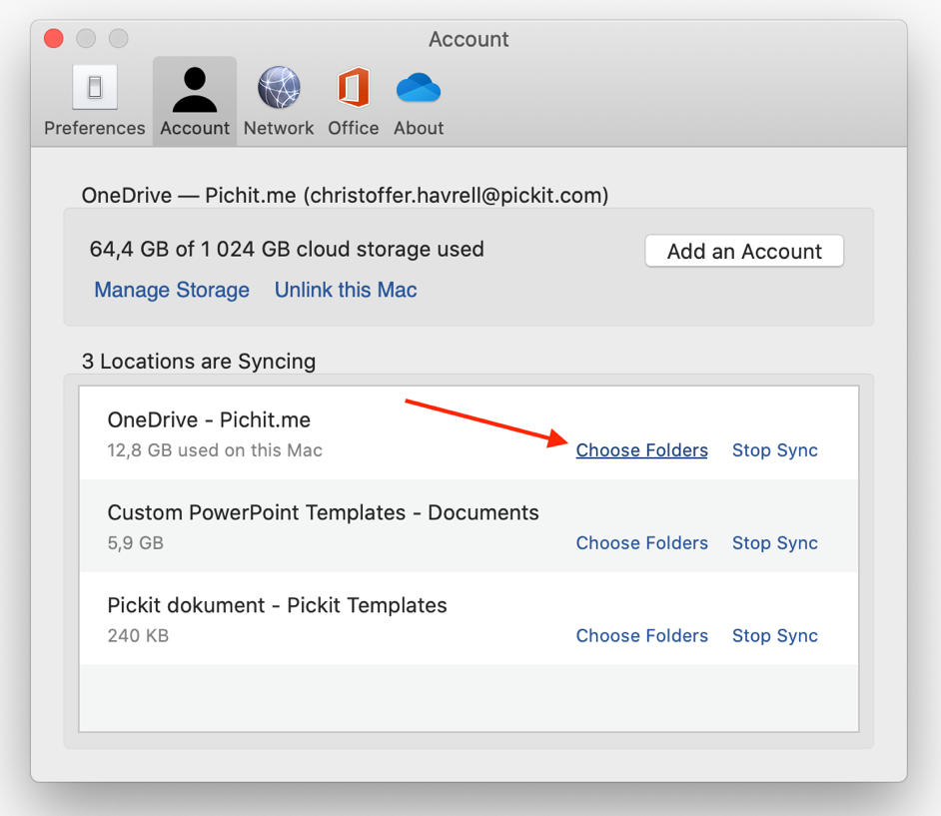

Set up the OneDrive folder as the Workgroup Templates location in Word

For Windows
The user needs to set up the OneDrive folder location on their computer as the Workgroup Templates location within Word. Once set it up in Word, it will automatically work in Excel, PowerPoint etc.
- In Word, click File > Options and in the Advanced category scroll down to the General section and click the File Locations button.
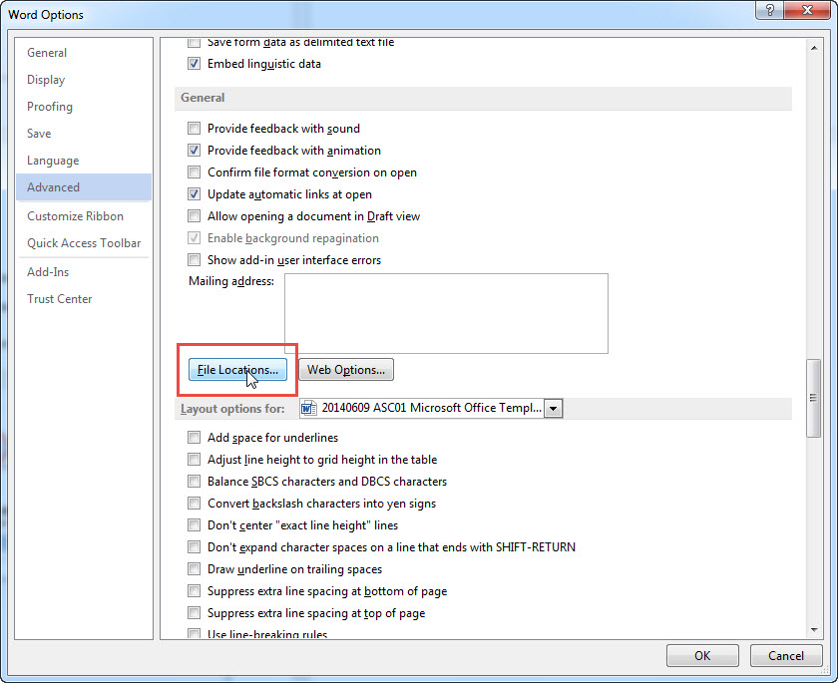

- Select Workgroup templates, then click on Modify and set the network share to be the template source.

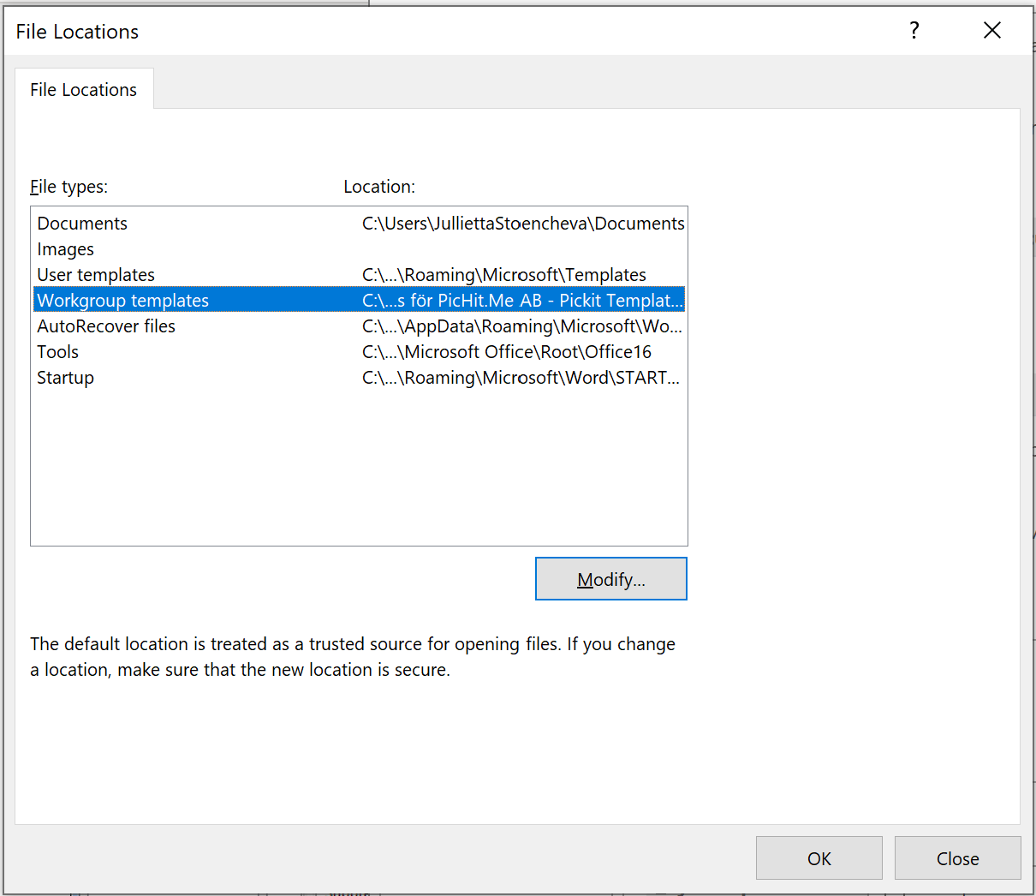

The user then also needs to set the folder location as a trusted location in the Trust Center.
- Click File > Options.
- Click Trust Center > Trust Center Settings > Trusted Locations.
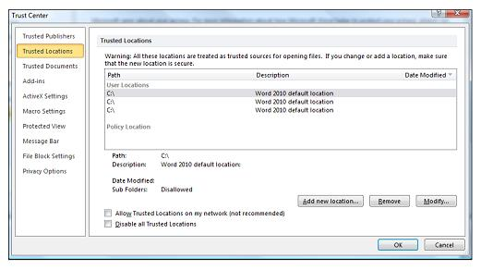
- Click Add new location.
- Click Browse to find the folder, select a folder, and then click OK.
(If you have subfolders within the template folder, then there's a little tick box for including subfolders in the trusted location.)

This action sets the network share for Excel and PowerPoint as well. In any of these programs, you can choose File > New. Click on the SHARED tab and select the template you want to open.

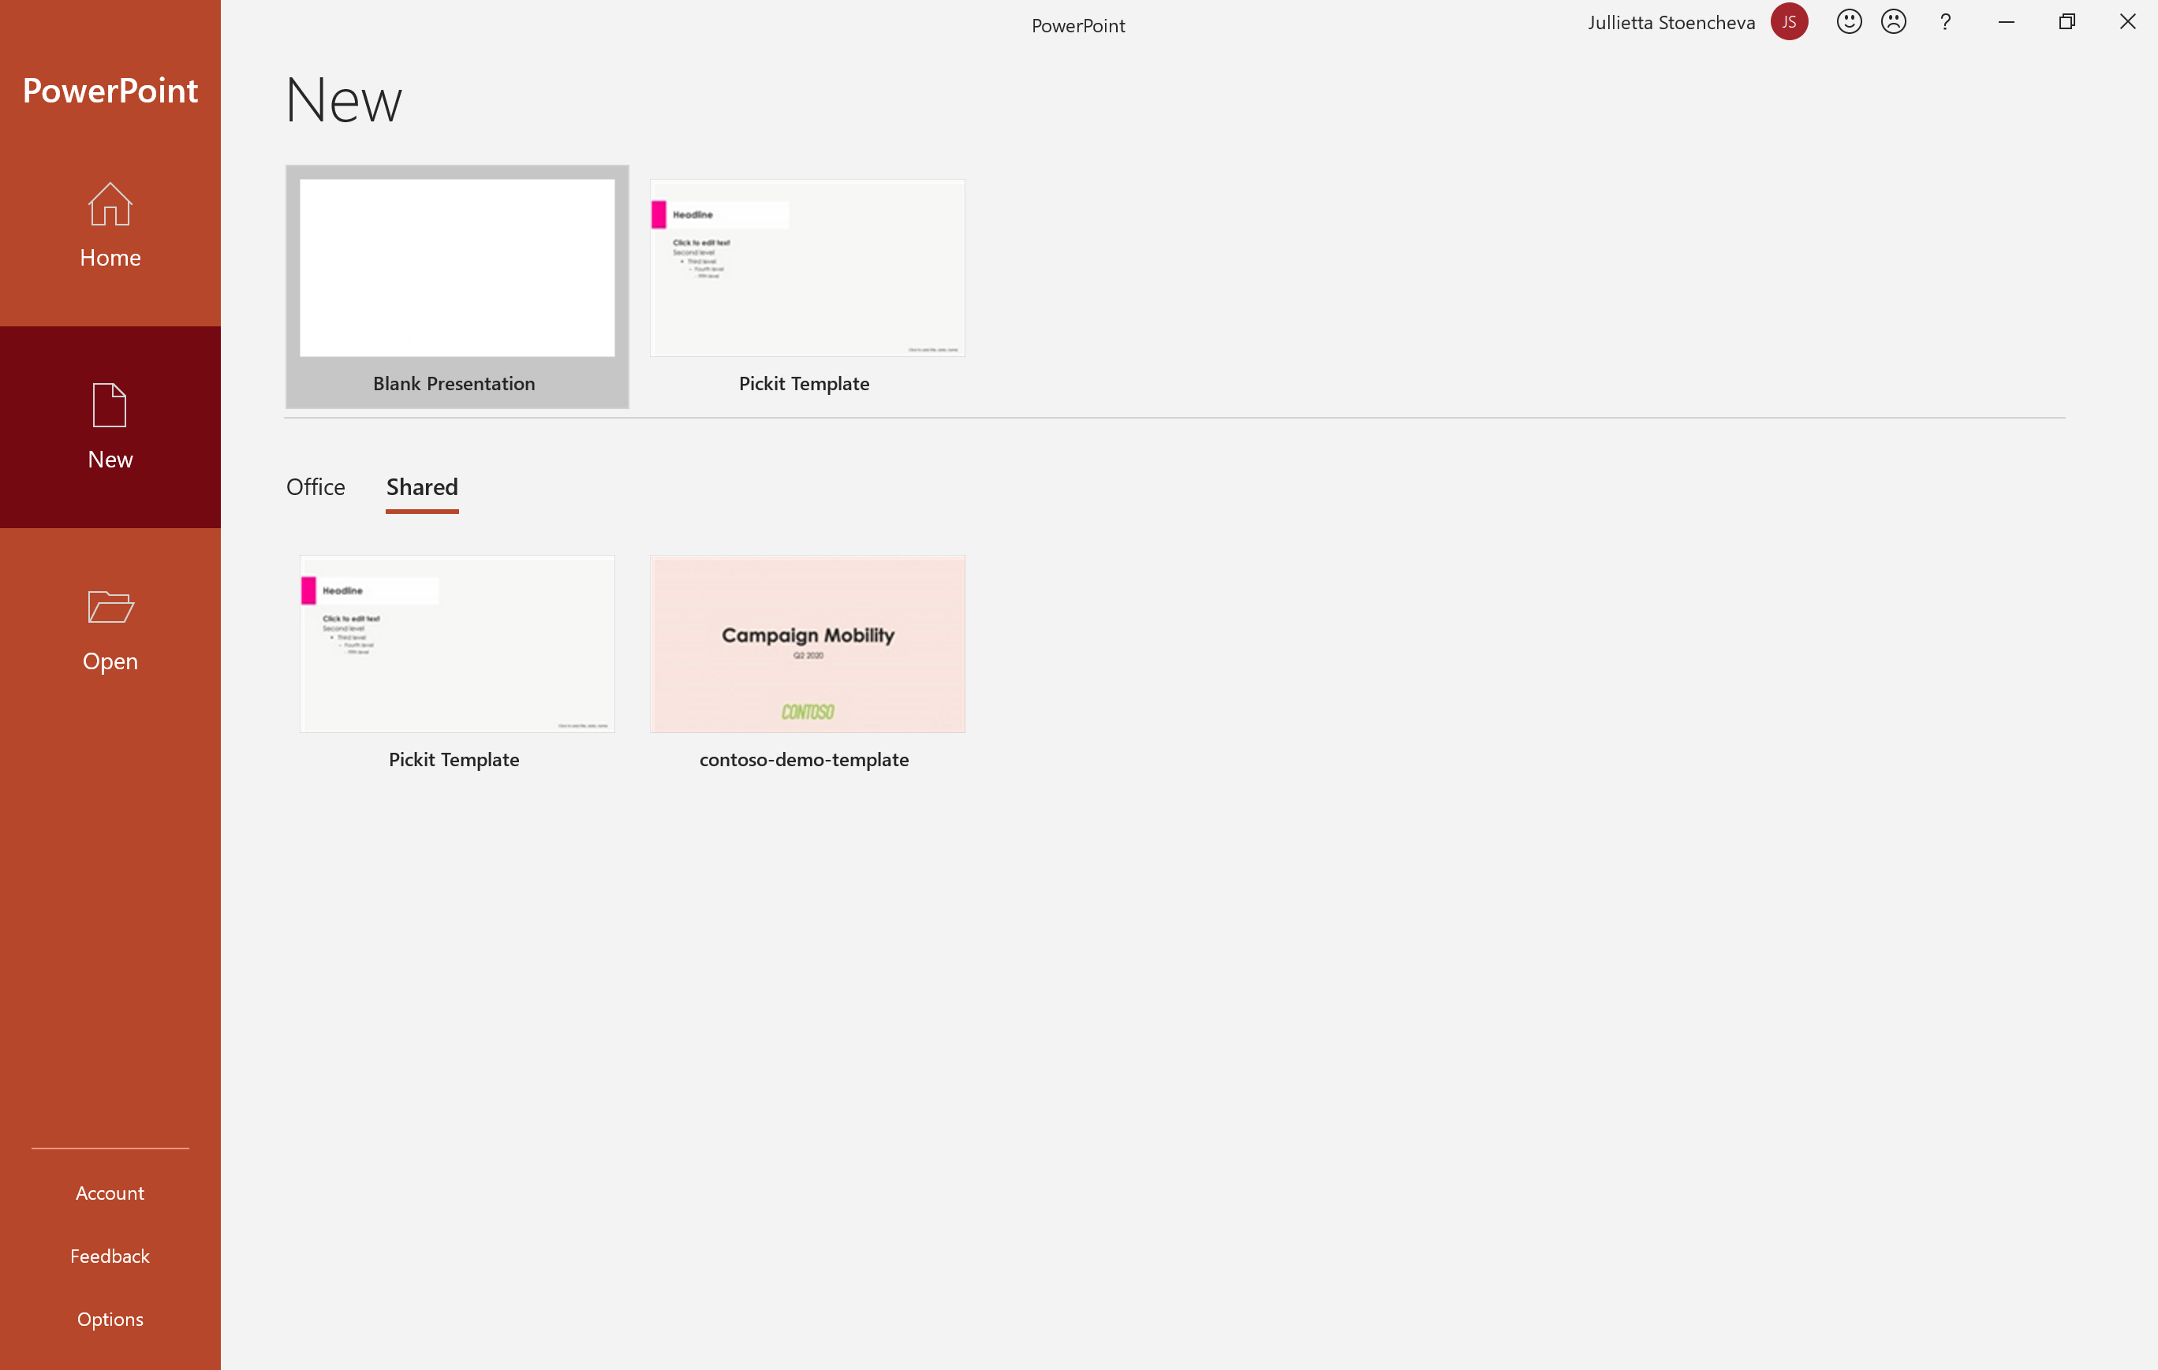

For Mac
Start by opening Microsoft Word and then in the top Finder navigation click Word > Preferences, then under Personal settings click File Locations.

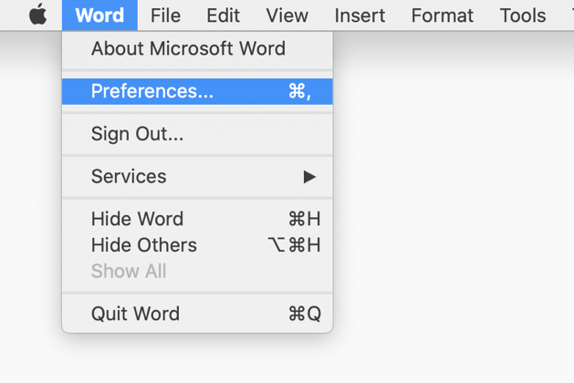
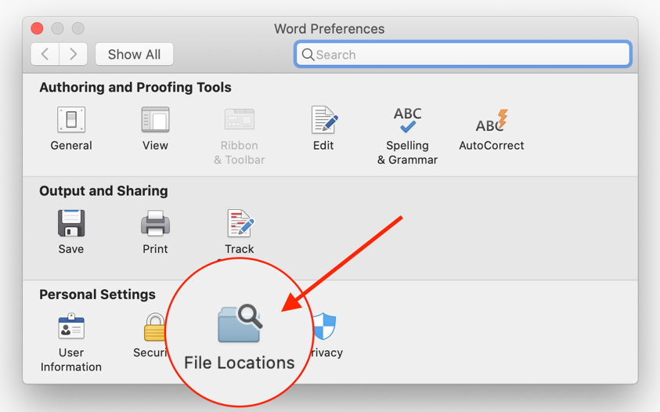

Here, you need to select Workgroup Templates, then click Modify to define or navigate to the globally shared template folder you created on SharePoint. Once this is defined, all the templates defined or placed in the folder should be available in the New section under the tab Work. Only program specific template files will be displayed, ex. for PowerPoint only .POTX should be listed here, in Word - only .DOTX files, etc.

This action sets the network share for Excel and PowerPoint as well. In any of these programs, you can choose File > New. Click on the WORK tab and select the template you want to open.

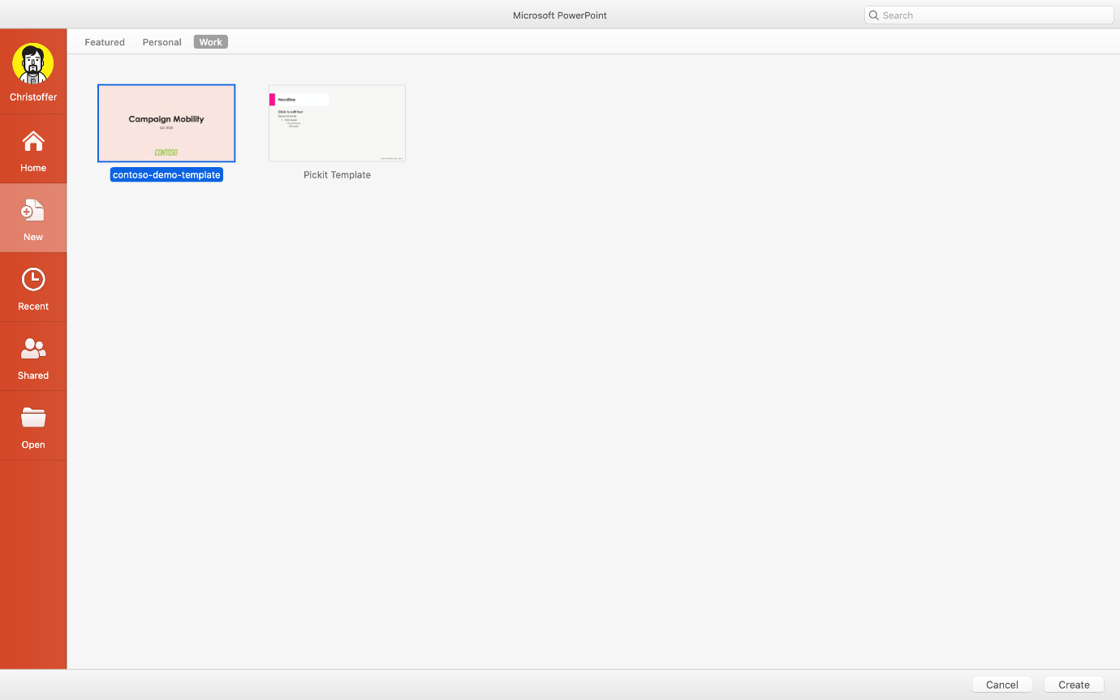

And that’s it! To update the templates, just replace the files on the network share.

