Clear the Cache of Add-ins
  - Edge Task Pane

Contents
Installation 2
Clear Cache 4

Installation
- Open the Microsoft Store either by clicking the icon in the task bar or search for store in the Windows search field.
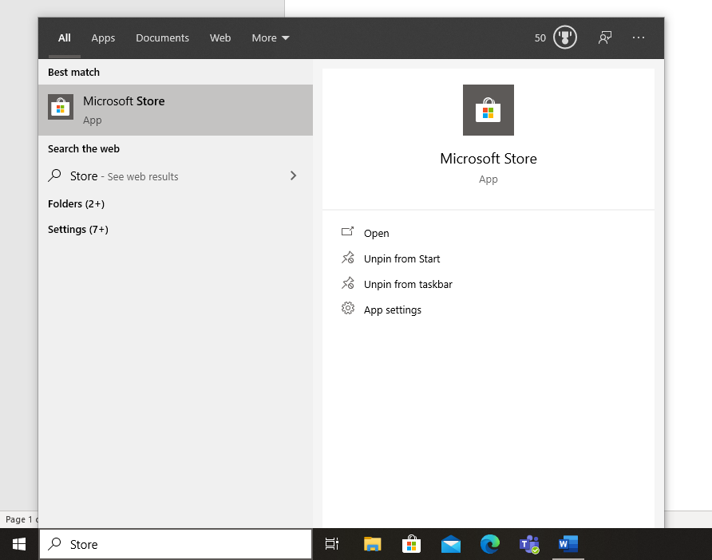
- Search for Edge developer tools and choose Microsoft Edge DevTools Preview
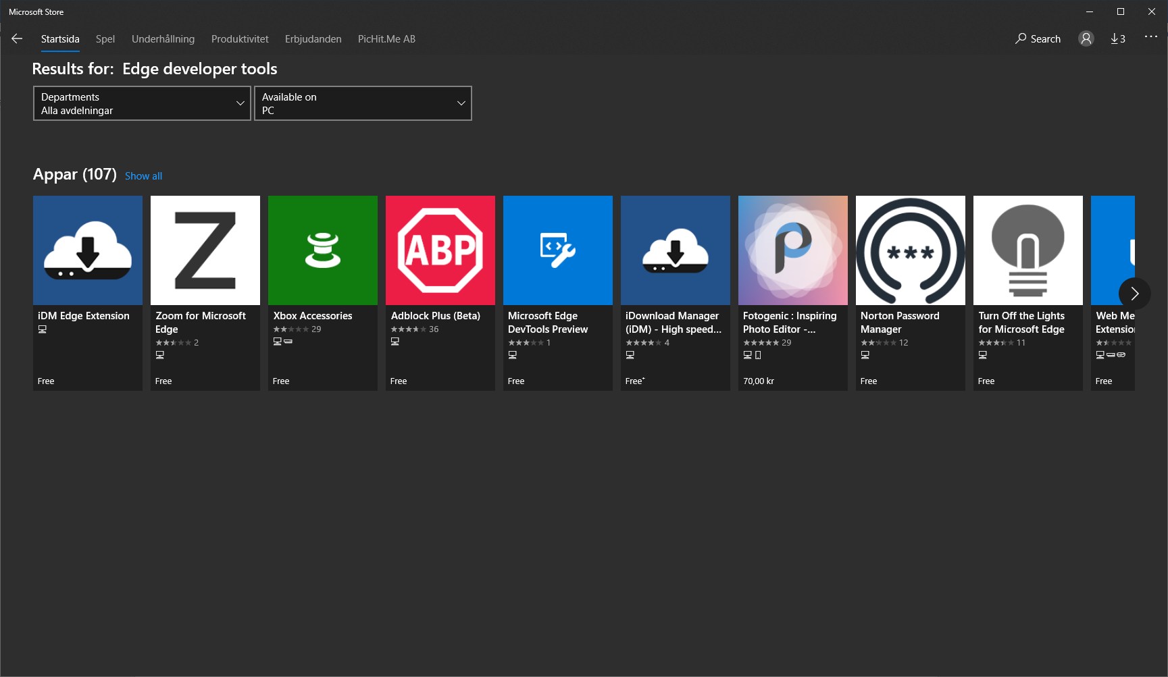
3.Press the Get button and the tools will be downloaded and installed.
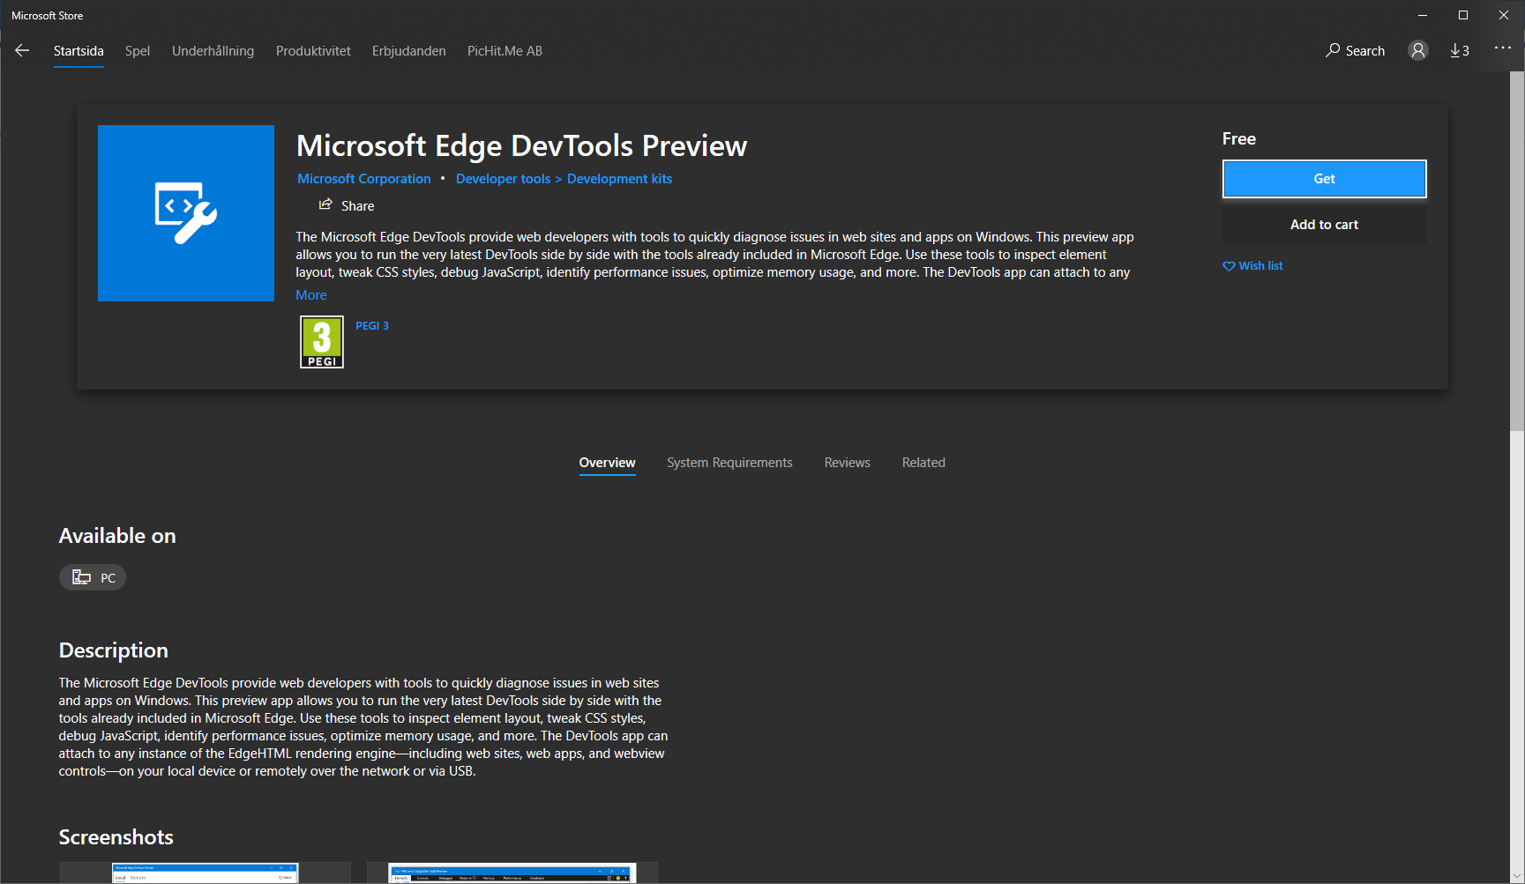

Clear Cache
- Open Microsoft Edge DevTools Preview
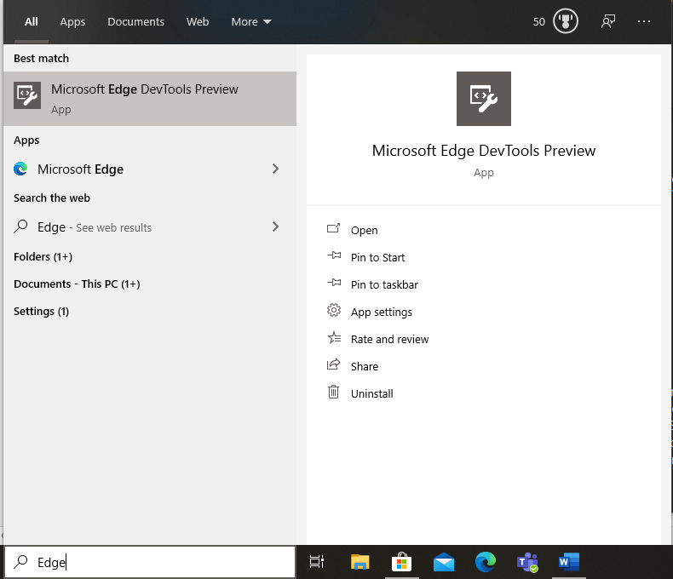
- Select Pickit. Note that you need to have the Pickit add-in in Office open in order for it to appear in the app.
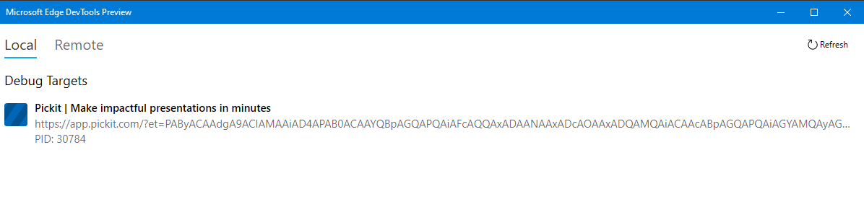

- Clear the cache by:
  - Go to the Storage tab
  - Expand the Local Storage option and select app.pickit.com
  - Select the first option in the list and press delete to remove it, Keep deleting until the list is empty
