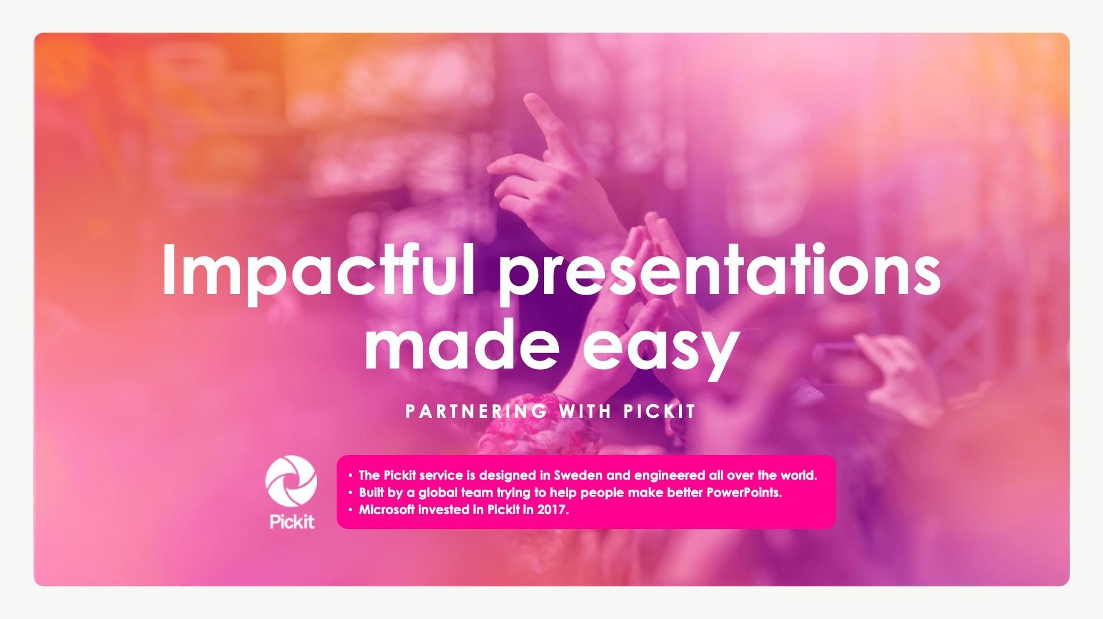

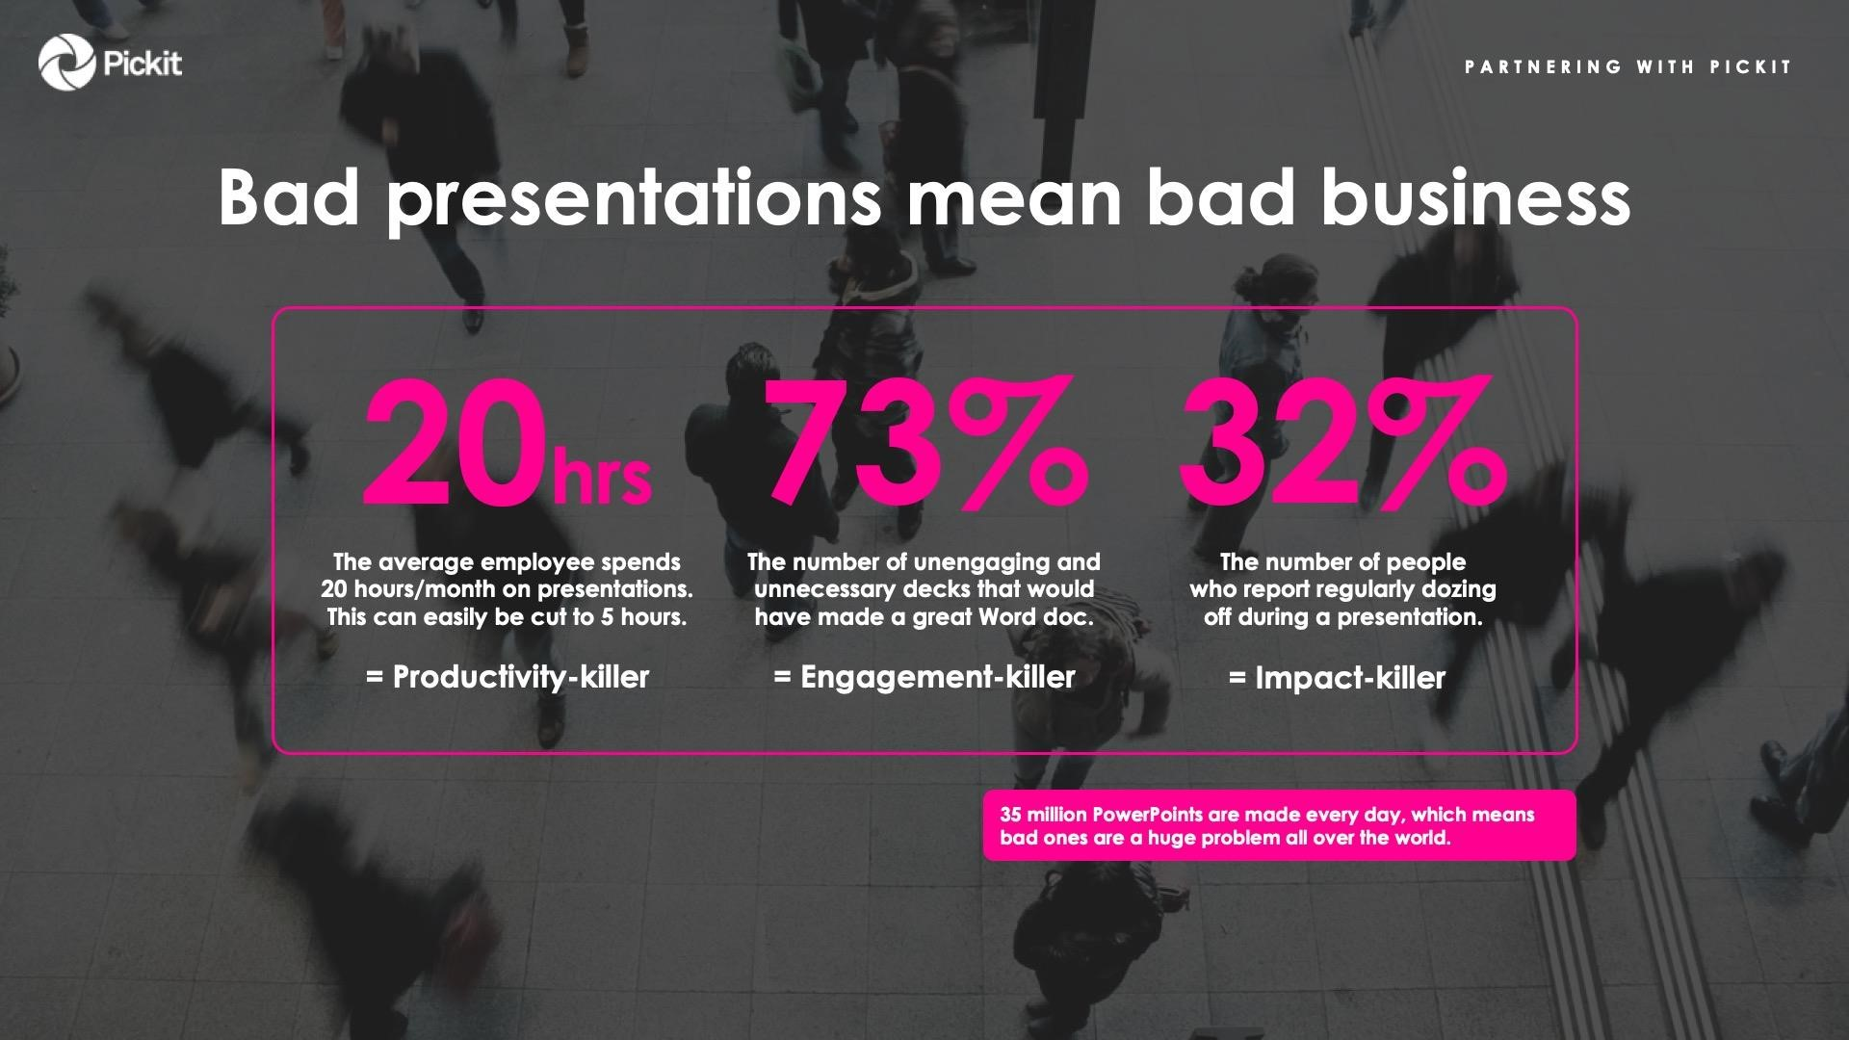



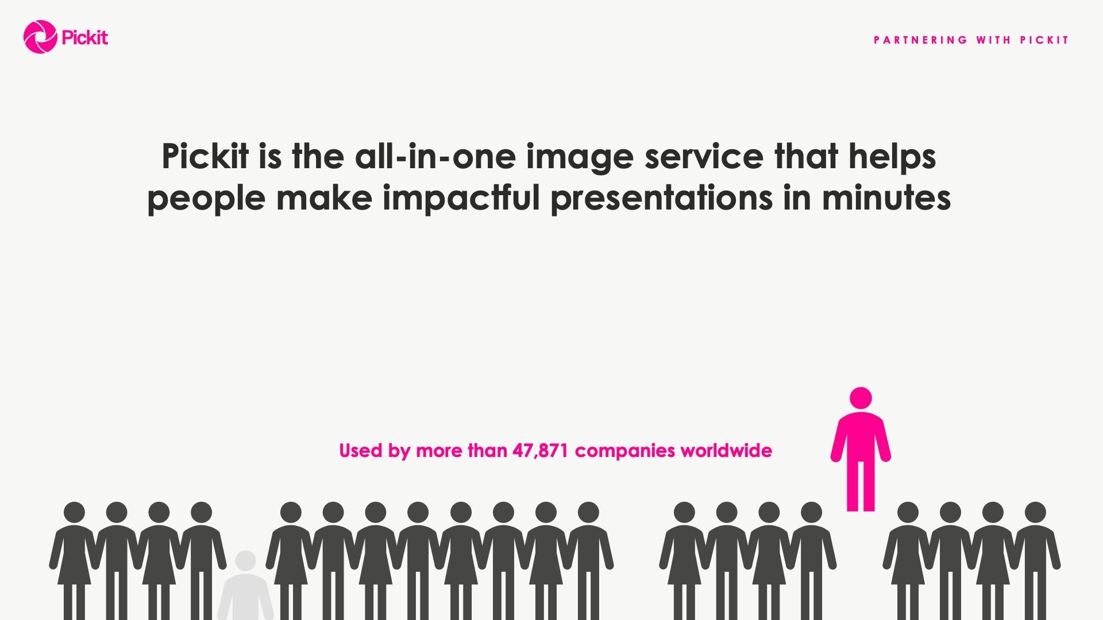

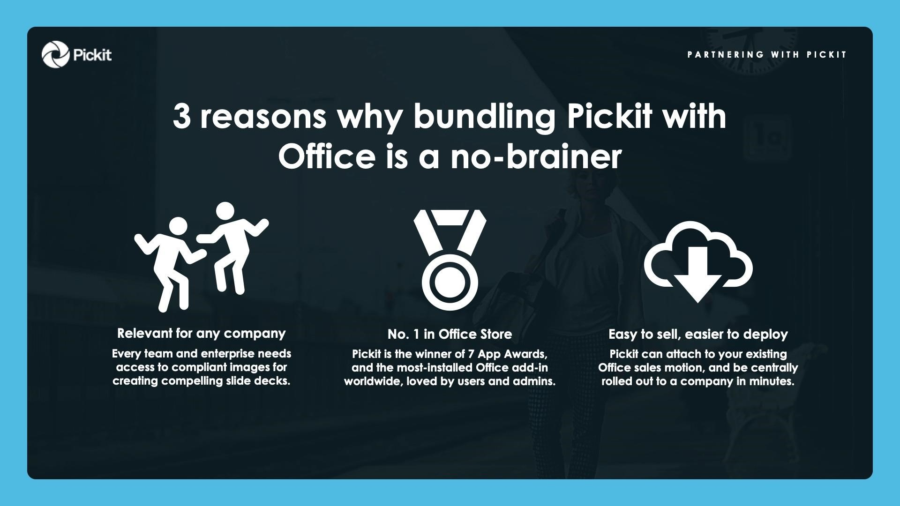

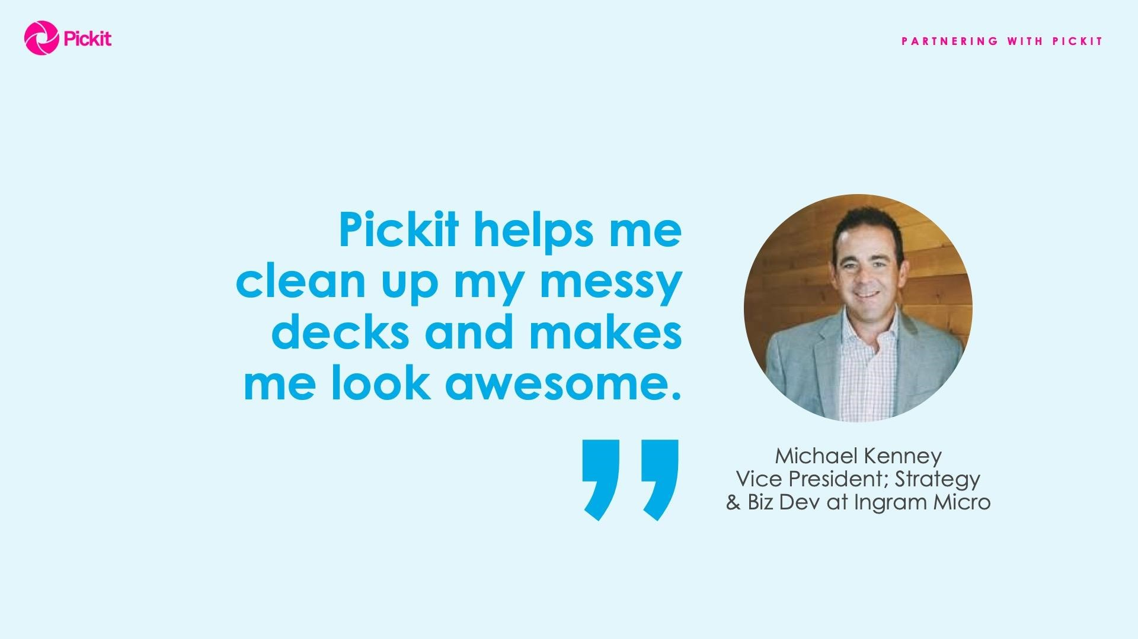

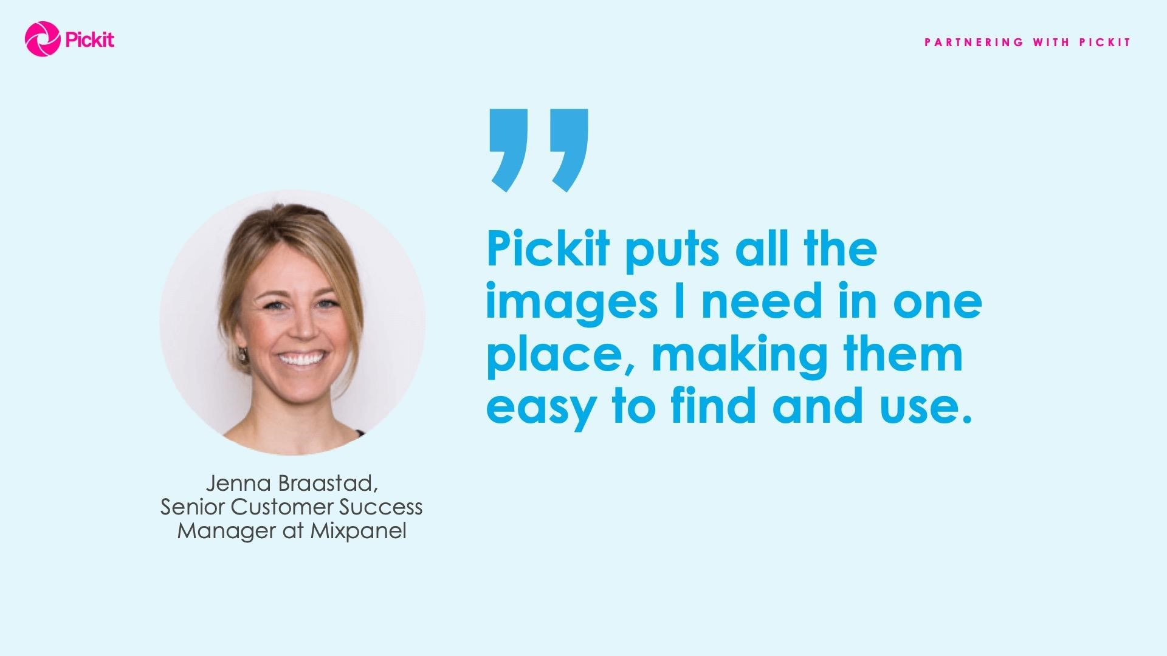

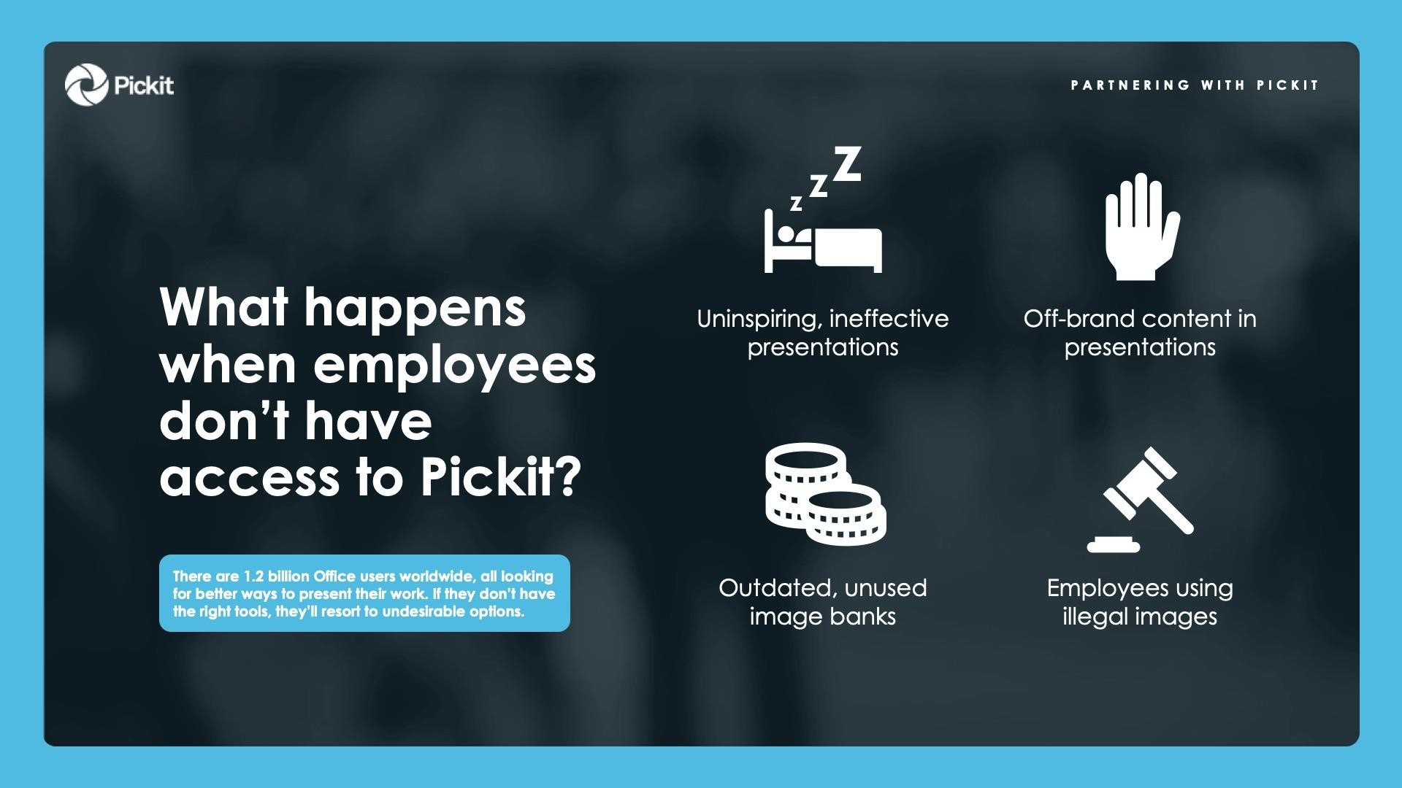

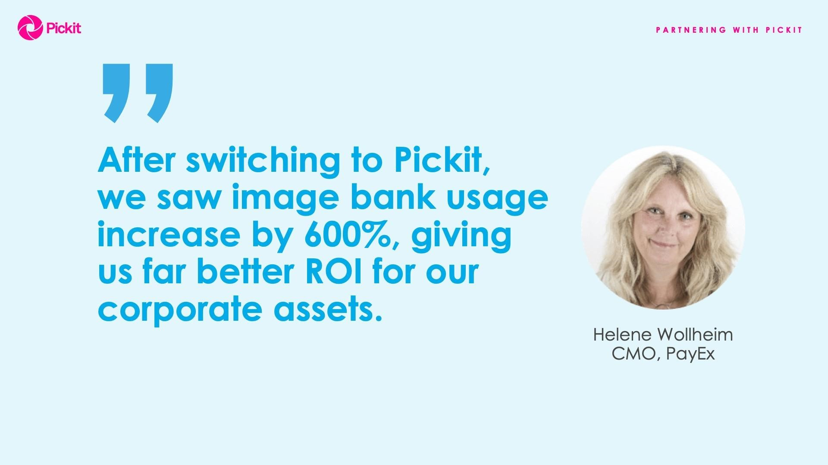

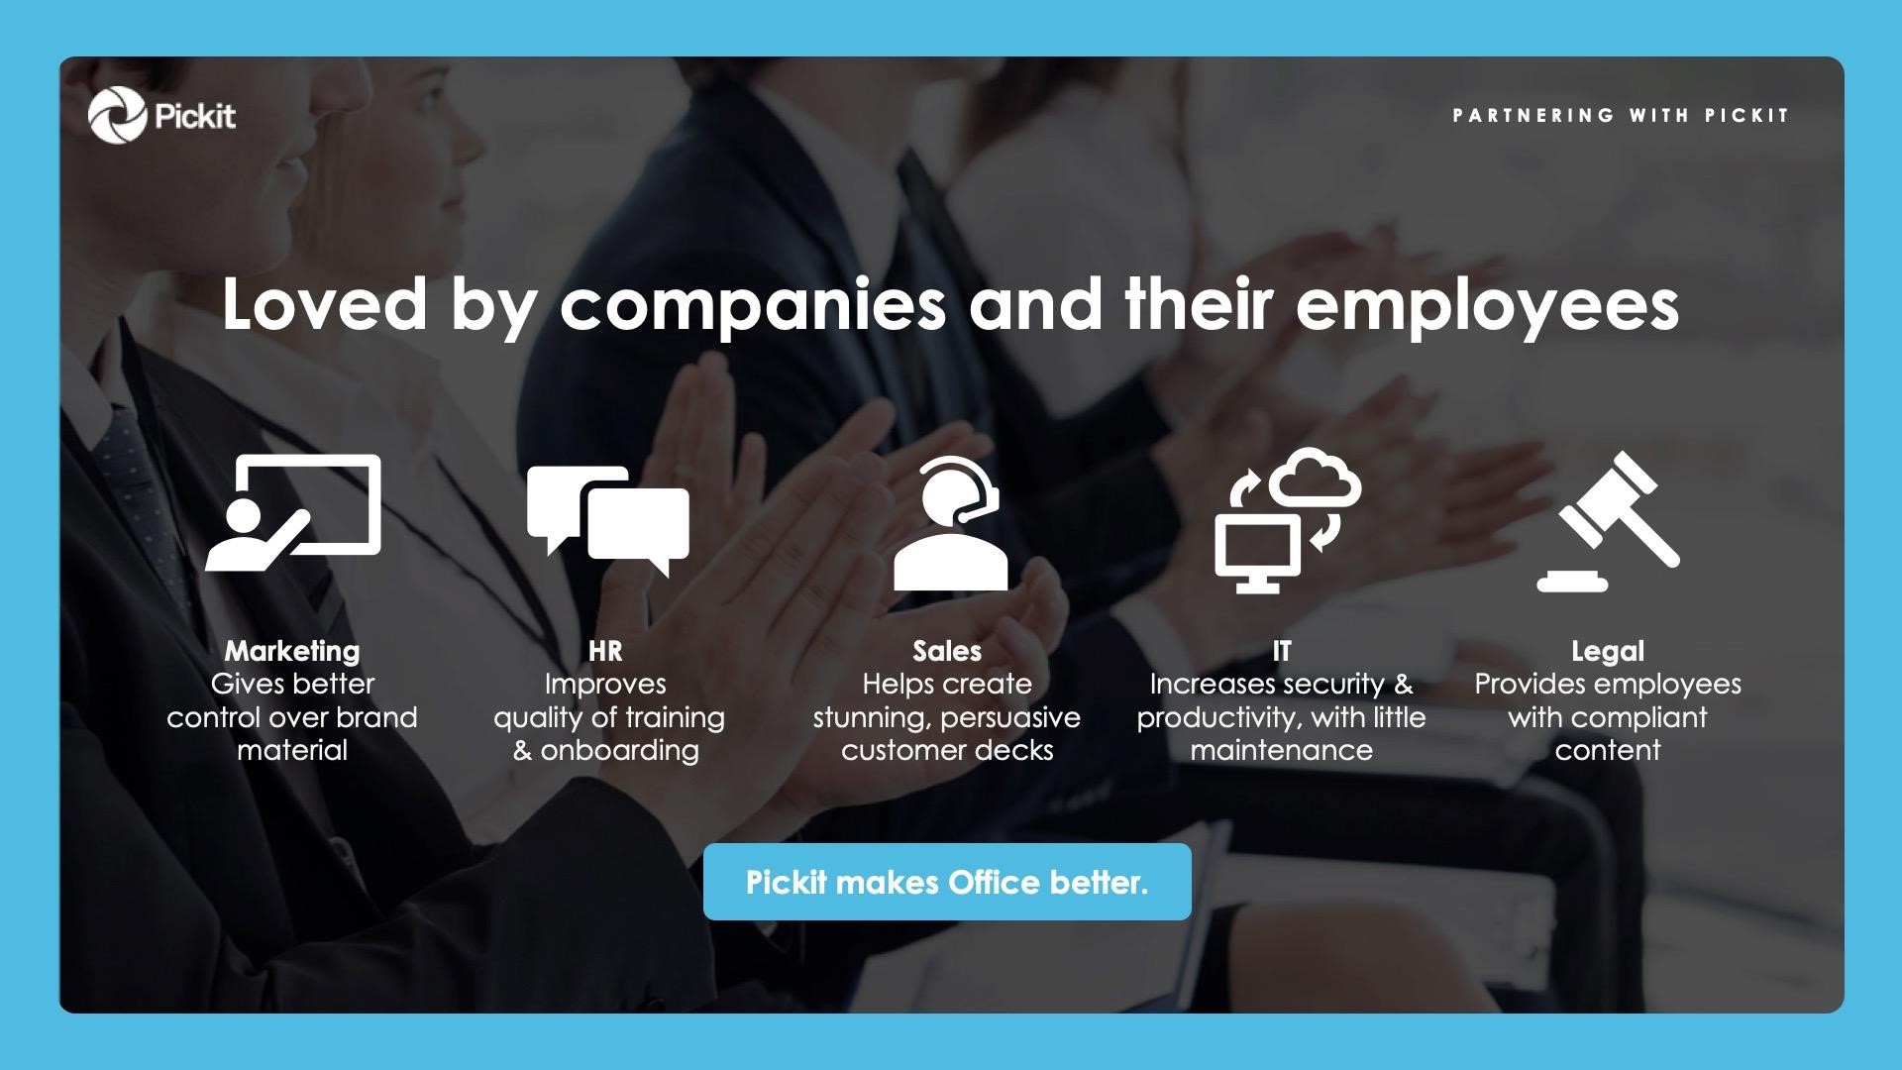

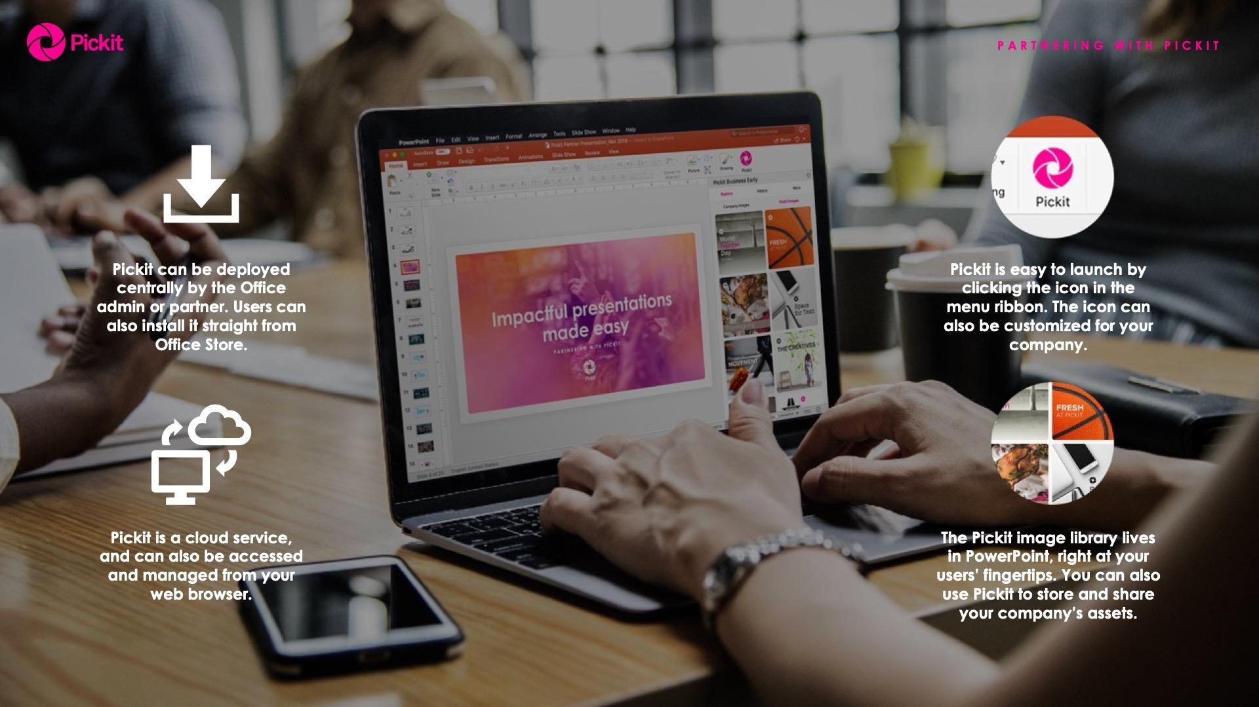

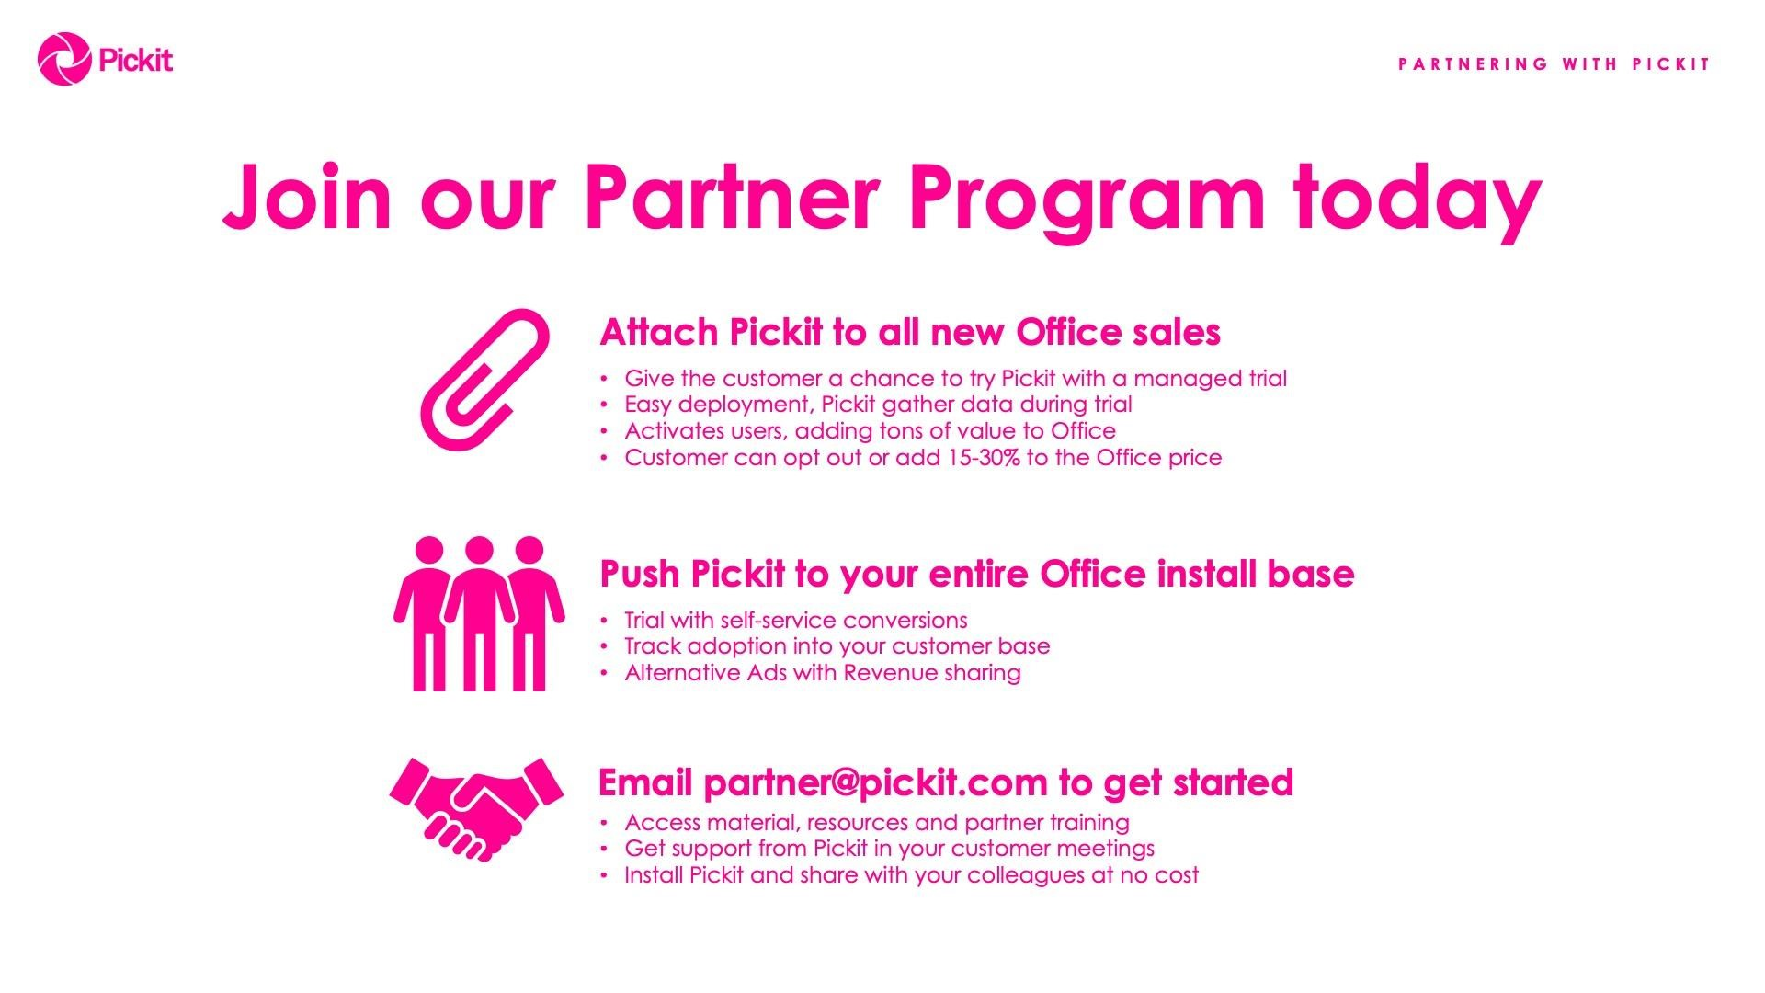

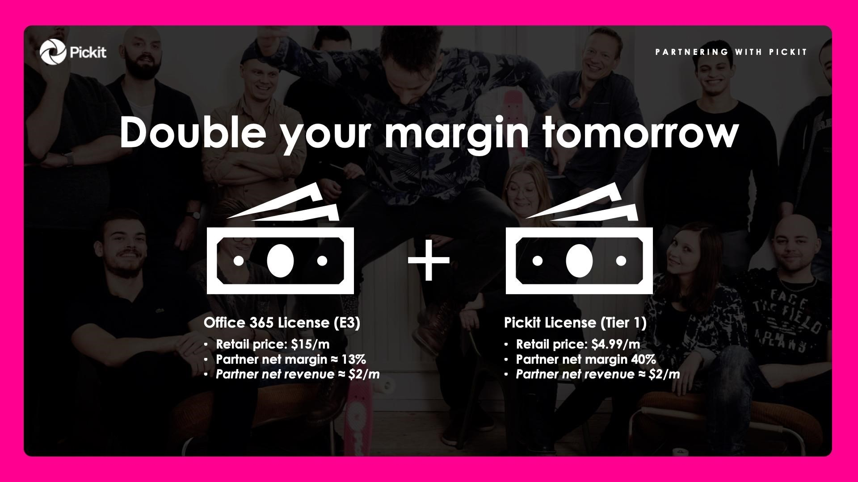

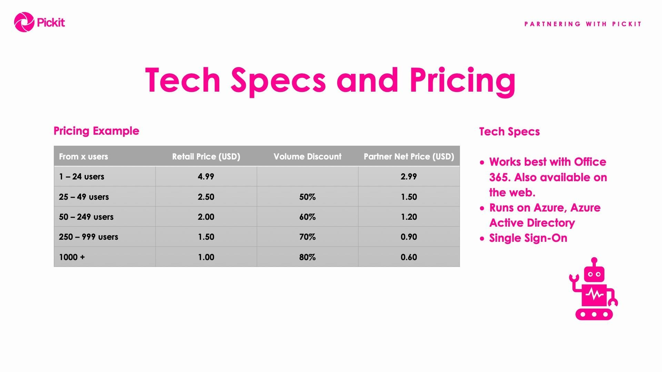

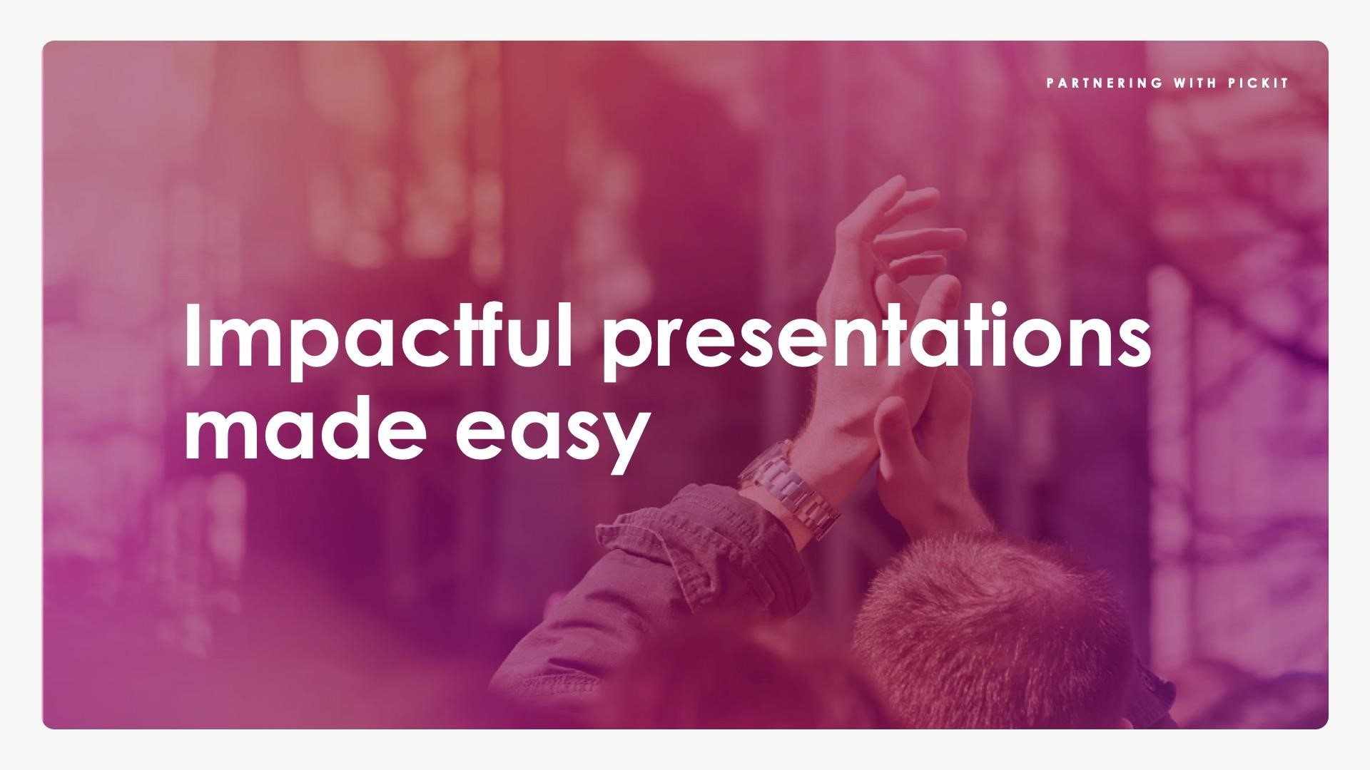

**See Microsoft CEO, Satya Nadella, highlight**

**Pickit**

**at Build**

[**https://youtu.be/ftFdW4YZZiU?t=1m17**](https://youtu.be/ftFdW4YZZiU?t=1m17s)

[**s**](https://youtu.be/ftFdW4YZZiU?t=1m17s)

**Hear Microsoft Corporate VP, Gavriella Schuster, feature**

**Pickit**

**in her keynote at Inspire**

[**https://vimeo.com/280445078#t=1255**](https://vimeo.com/280445078#t=1255s)

[**s**](https://vimeo.com/280445078#t=1255s)

