Pickit Edu

Data Sheet

Saving schools and universities from boring docs and presentations

Pickit Edu makes it easy to save time and make your work stand out with unlimited images right inside Office 365. Pickit’s award-winning app puts royalty-free photos, icons and illustrations at your fingertips right inside PowerPoint and Word.

Pickit is a cross-platform Azure-based service that works with Windows 10, Mac, Office Online & Office for iPad. Pickit Add-ins are available for PowerPoint & Word and can be downloaded from Microsoft AppSource.

What We Offer
Curated content
Images are organized in professionally curated collections using AI and a team of curators. Users can search for specific images or browse collections for inspiration and advice.
Royalty-free images
All images are legally cleared and free to use for anything. Model releases are included and the image providers are rewarded. We set on making Fair Photos the new norm.
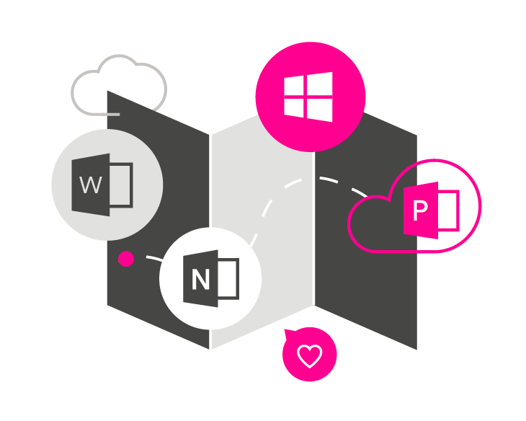
Seamless Office integration
Award-winning Office apps enable users to quickly source images right from the task pane in PowerPoint and Word. This helps maximize Office, simplify workflows and dramatically increase productivity.

A Few Numbers

Replacing ClipArt for over 1 billion Office users
Microsoft Office users are used to in-app access to images for documents and presentations. Pickit Edu provides an up-to-date solution to replace ClipArt to the world’s 1 billion Office users.

97% of searches get results
Pickit’s in-app search is reliable and accurate, yielding relevant results almost every time, making the service an effective and more convenient alternative to traditional search engines.

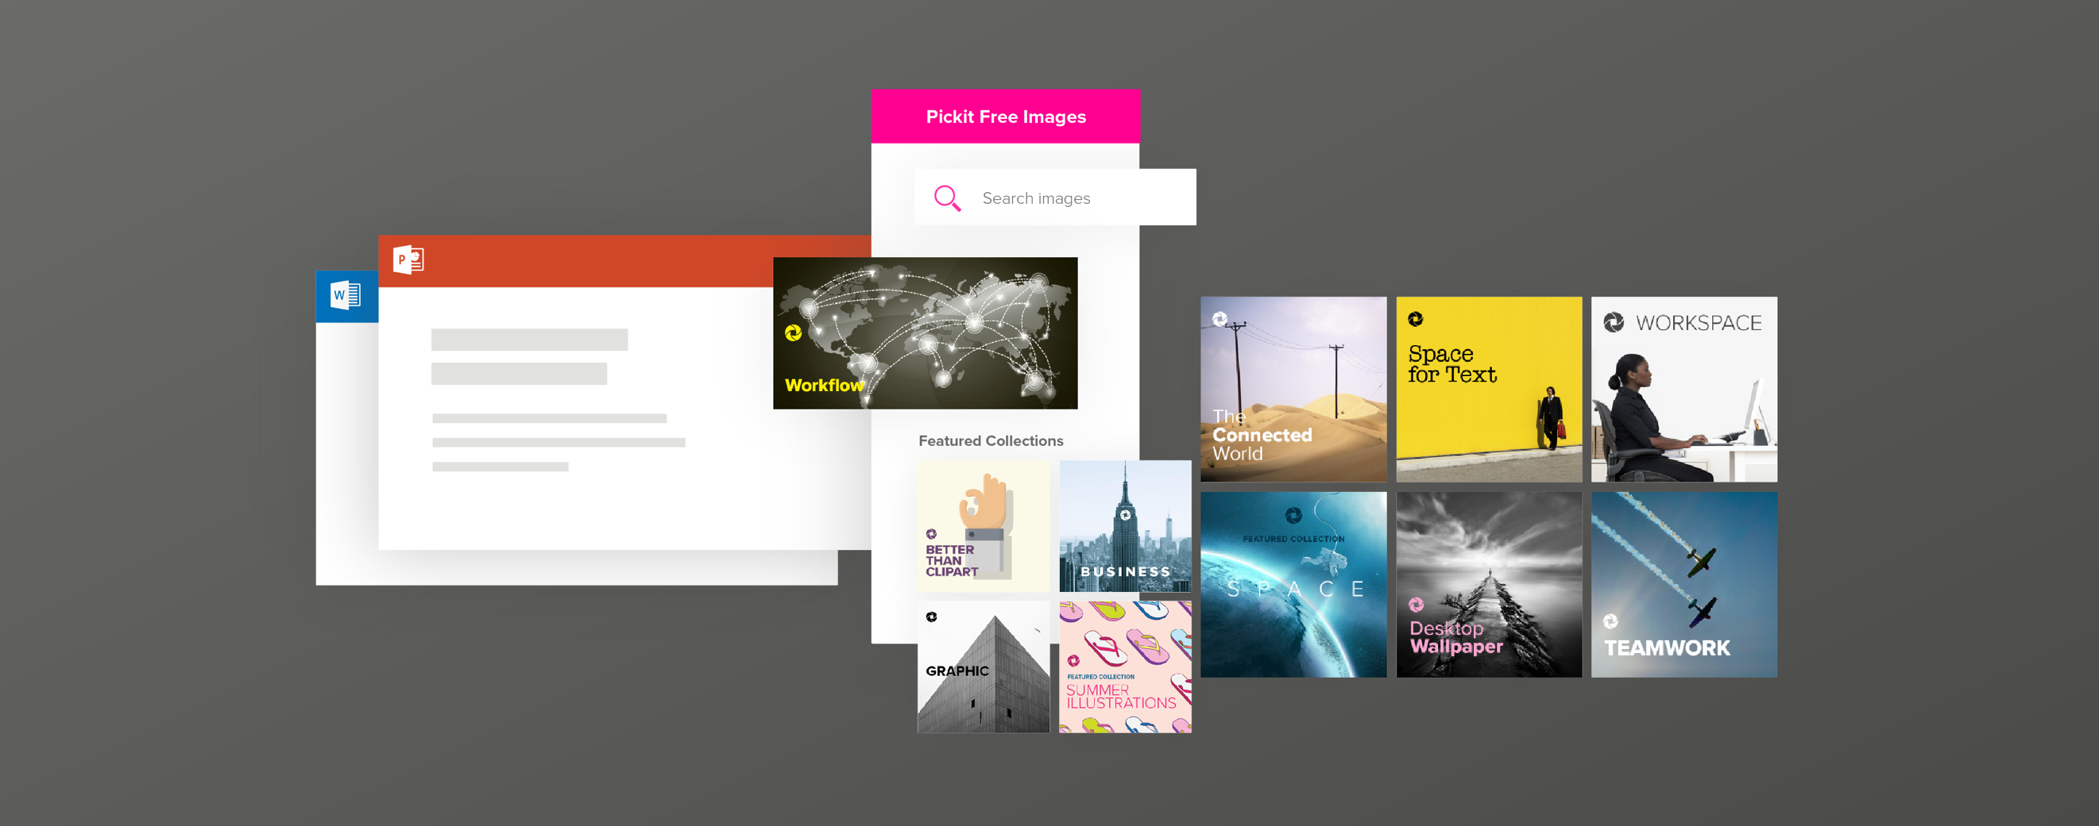

Key Use Cases

Source licensed images
85% of images downloaded from the internet are illegal. Pickit solves that with legally cleared photos, icons & illustrations.

Save time in PPT, Excel & Word
The average presentation has 7 images. Finding them in folders and search engines can be time-consuming. Pickit increases productivity in PPT & Word.

Get unique content
Sourcing custom images from stock photo providers and agencies can be expensive. Pickit puts a global photographer community a click away.

What Our Customers Are Saying

“We’re constantly updating and managing large amounts of images across our organization. Pickit makes it simple, giving us the overview, security and control we need.”
- Anna Fohlin Brand Manager at Svenska Spel

“Pickit helps us align our work across all our offices, which are spread out. The easy-to-use interface really makes our work and our image bank more efficient.”
- Lars Mårdbrandt Head of Communication at ALMI

